Revision History
Date | Version | Description | Author
<25/10/2017> | <1.0> | The document for the requirements of the Art of Shock: Impact software. | Bora Berk Akdeniz, Atakan Atamerk, Orkun Doğan, Sami Menteş, Oğulcan Cingiler

TABLE OF CONTENTS
Revision History 1
1 INTRODUCTION 3
1.1 Document overview 3
1.2 Abbreviations 3
1.3 References 3
1.4 Conventions 3
2 REQUIREMENTS 5
2.1 User Requirements Specification 5
2.2 System Architecture 5
2.3 Use Cases and Usage Scenarios 5
2.4 System Requirements Specification 5

INTRODUCTION

Document overview

This document presents the software requirements specifications of Art of Shock: Impact (ASI) software development project. It describes functional requirements, quality requirements, constraints, use cases, and usage scenarios. It also provides an overview of the system architecture.

System overview
This system will be based on Windows OS systems with x86 architecture. The system will be a single program running on Unreal Engine 4 (UE4) and the user (player) will be directly communicating with the program via keyboard and mouse inputs. The in-game character will be functioning according to the inputs given by the user. Since the game is designed as a multiplayer game, a second player will be giving inputs on another device and the game will be receiving the inputs of the second player from an internet connection.

Abbreviations
XXX: <The name of the software system to be developed>
UML: Unified Modeling Language
SRS: Software Requirement Specification
STP: Software Test Plan
UE4: Unreal Engine 4
OS: Operating System
ASI: Art of Shock: Impact
LMB: Left Mouse Button
RMB: Right Mouse Button
KDR: Kill/Death Ratio

References

# | Document Identifier | Document Title
3549 | ASI-SDP | Software Development Plan of Art of Shock: Impact Software

Conventions
Requirements listed in this document are constructed according to the following structure:

SRS-XXX-000
Description of XXX-000 requirement
Version of XXX-000

Every system requirement id includes the id of the corresponding user requirement as a prefix.

SRS-XXX-000.1
Description of XXX-000.1 system requirement, which is related to the user requirement XXX-000
Version of XXX-000.1

REQUIREMENTS

User Requirements Specification

SRS-ASI-001
ASI software shall provide the user with a HUD, showing the player’s health, remaining ammunition in the magazine, for the in-game character where the user can see enemies and environment objects, and the user will be free to act however they wish to.
V1.0

SRS-ASI-002
There shall be a scoreboard for the player on which they will be evaluated at the end of the game where they will be ranked accordingly.
V1.0

SRS-ASI-003
The character shall be moving according to the keyboard and mouse inputs. Also the currently equipped weapon shall be used with predetermined mouse inputs.

SRS-ASI-004
When a player dies, the currently running game shall conclude, where the player who has died is the loser and the other player is the winner.

SRS-ASI-005
3D arena type of map shall be used and the objects shall have a futuristic theme.

SRS-ASI-006
Nicknames shall be taken from the Steam servers.

SRS-ASI-007
Matchmaking shall be used in order to find an opponent for the player who is on the same skill level. Players shall be able to invite their friends as well.

SRS-ASI-008
There shall be a main menu when the software is run. The users will have options to either start the game, adjust certain options of the game or quit the game.

System Architecture

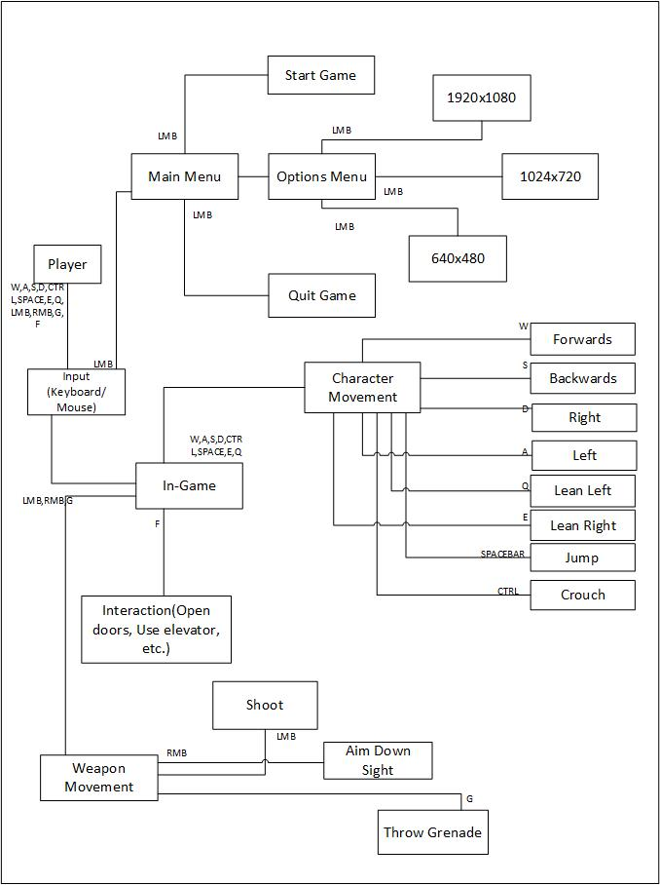
Client 1



Web

Client 2

Client 1 & 2 will be updating the program data simultaneously according to the data received from the Steam servers. The states of both players will be updated and exchanged between the clients via the Web.

Use Cases and Usage Scenarios

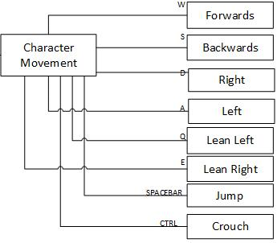
Character movement use cases

Weapon movement use cases
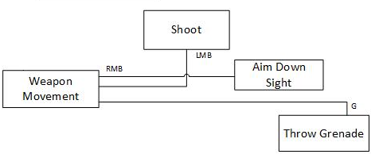

Menu use cases
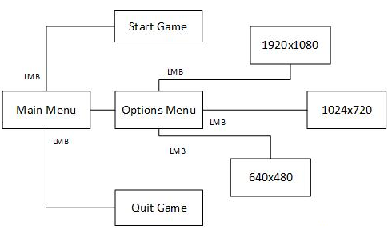

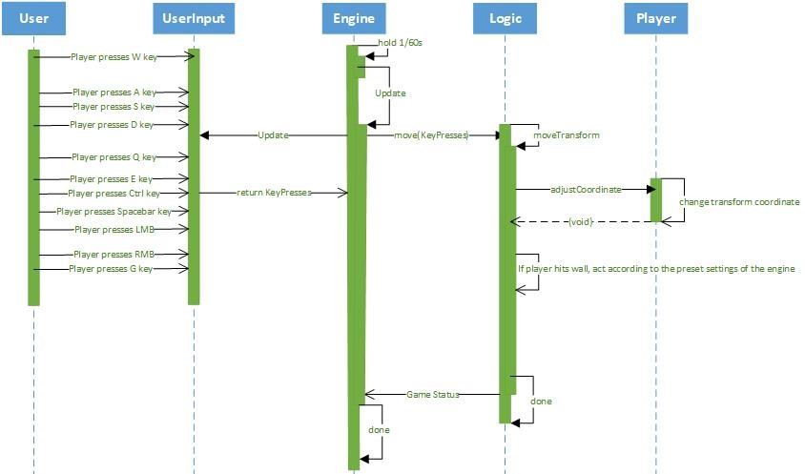

System Requirements Specification
SRS-ASI-001.1
ASI makes sure that the displayed data on the HUD is the same as the actual data in the Steam Servers.
The displayed data is:
- Enemy player’s nickname,
- Remaining health points
- Remaining shield amount
- Remaining ammunition
- The weapon in use
- Crosshair
- Stamina
- Scoreboard (TAB Menu)
V1.0

SRS-ASI-002.1
ASI scoreboard will be showing essential data on the game.
The data is:
- Kill/Death count (ratio)
- Points/Score
- Nicknames
- Profile picture
- Rank
V1.0

SRS-ASI-003.1
The ASI software shall allow the players to move around in the game by using the keyboard inputs such as W, A, S and D keys on the keyboard. The Ctrl key shall allow the players to crouch and the Spacebar shall allow the users to jump with their characters in game. ASI software shall allow players to look around using their mouse, simply moving the mouse left, right, up or down will let players rotate their view to the corresponding directions. The left mouse button shall allow players to shoot with their currently equipped weapon and the right mouse button shall allow players to aim down the sights with their currently equipped weapon.
V1.0

SRS-ASI-004.1
The currently running game session in the ASI software shall conclude when either one of the players have died. Meaning when either one of the players reaches 0 health points, the currently running game shall conclude with the player with more than 0 health points as the winner and the player with 0 health points as the loser. If no players reach zero health points within the time limit, the game shall conclude as a draw. Meaning the game will not register as a win nor a loss for neither of the players.
V1.0

SRS-ASI-005.1
ASI software shall provide the players with an arena sized map with obstacles, walls etc. to use strategically to outsmart their opponents. The maps shall have a 3D model with futuristic themed models and graphic designs.
V1.0
SRS-ASI-005.2
The frames per second (FPS) when the game is running shall not have any sudden spikes. The FPS shall also stay above 30 FPS at all times provided that the minimum system requirements are met.

SRS-ASI-006.1
ASI software shall obtain the nicknames of the players from their Steam account names (nicknames). By doing so, ASI will provide ease of access for the players who will not have a hard time choosing a nickname for themselves.
V1.0

SRS-ASI-007.1
ASI shall allow players to invite their friends to a match so they can play together, otherwise ASI’s normal, matchmaking system will be automatically done by the software by considering certain criteria’s such as a player’s level or how well they’ve performed so far, meaning their total points or their KDR.
V1.0

SRS-ASI-008.1
ASI shall have a main menu for players to interact with the software directly, to change some settings, such as resolution, start or quit the game. The main menu shall have a background as a visual asset; the buttons on the main menu shall have their own designs and interactive sounds.

